Physical Model

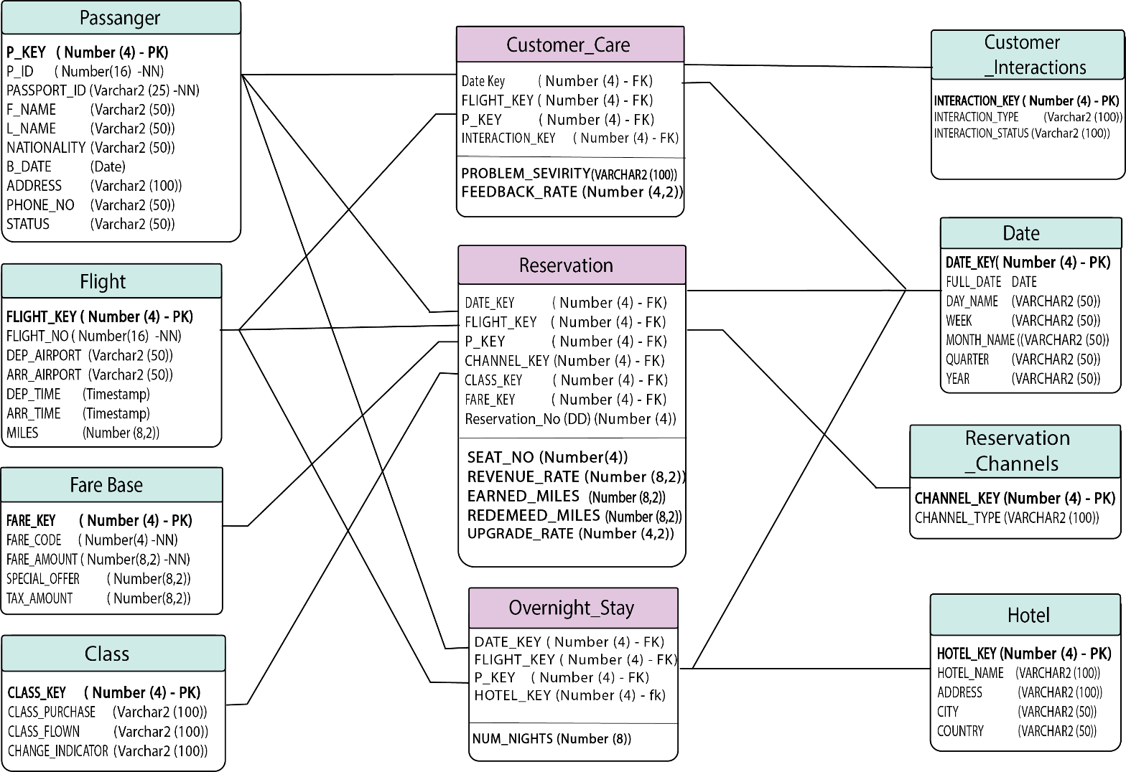

Dimension Tables:

CREATE TABLE passenger

(

P_Key NUMBER (4) CONSTRAINT passenger_PK PRIMARY KEY,

p_id NUMBER (16) NOT NULL,

passport_id VARCHAR2 (25) NOT NULL,

f_name VARCHAR2 (50),

l_name VARCHAR2 (50),

nationality VARCHAR2 (50),

b_date DATE,

address VARCHAR2 (100),

phone_no VARCHAR2 (50),

status VARCHAR (50)

);

CREATE TABLE flight

(

flight_Key NUMBER (4) CONSTRAINT flight_PK PRIMARY KEY,

flight_no NUMBER (16) NOT NULL,

dep_airport VARCHAR2 (50),

arr_airport VARCHAR2 (50),

dep_time TIMESTAMP,

arr_time TIMESTAMP,

miles NUMBER (8, 2)

);

CREATE TABLE fare_base

(

fare_Key NUMBER (4) CONSTRAINT fare_PK PRIMARY KEY,

fare_code NUMBER (4) NOT NULL,

fare_amount NUMBER (8, 2) NOT NULL,

special_offer NUMBER (8, 2),

Tax_amount NUMBER (8, 2)

);

CREATE TABLE class

(

class_Key NUMBER (4) CONSTRAINT class_PK PRIMARY KEY,

class_purchase VARCHAR2 (100),

class_flown VARCHAR2 (100),

change_indicator VARCHAR2 (100)

);

CREATE TABLE customer_interactions

(

interactions_Key NUMBER (4) CONSTRAINT interactionsr_PK PRIMARY KEY,

interactions_type VARCHAR2 (100),

interactions_status VARCHAR2 (100)

);

CREATE TABLE hotel

(

hotel_Key NUMBER (4) CONSTRAINT hotel_PK PRIMARY KEY,

hotel_name VARCHAR2 (100),

address VARCHAR2 (100),

city VARCHAR2 (50),

country VARCHAR2 (50)

);

CREATE TABLE reservation_channels

(

channel_Key NUMBER (4) CONSTRAINT channel_PK PRIMARY KEY,

channel_type VARCHAR2 (100)

);

CREATE TABLE date_dimension

(

date_Key NUMBER (4) CONSTRAINT date_PK PRIMARY KEY,

full_Date DATE,

day_name VARCHAR2 (50),

week VARCHAR2 (50),

month_name VARCHAR2 (50),

quarter VARCHAR2 (50),

year VARCHAR2 (50)

);

Fact Tables:

CREATE TABLE customer_care

(

date_key NUMBER (4),

flight_key NUMBER (4),

p_Key NUMBER (4),

interactions_Key NUMBER (4),

problem_severity VARCHAR2 (100),

feedback_rate NUMBER (4,2),

CONSTRAINT date_fk_cst FOREIGN KEY (date_key)

REFERENCES date_dimension (date_Key),

CONSTRAINT date_fk_flight FOREIGN KEY (flight_key)

REFERENCES flight (flight_key),

CONSTRAINT date_fk_pass FOREIGN KEY (p_Key)

REFERENCES passenger (p_Key),

CONSTRAINT date_fk_inter FOREIGN KEY (interactions_Key)

REFERENCES customer_interactions (interactions_Key)

);

CREATE TABLE overnight_stay

(

date_key NUMBER (4),

flight_key NUMBER (4),

p_Key NUMBER (4),

hotel_Key NUMBER (4),

num_nights NUMBER (8),

CONSTRAINT overnight_fk_cst FOREIGN KEY (date_key)

REFERENCES date_dimension (date_Key),

CONSTRAINT overnight_fk_flight FOREIGN KEY (flight_key)

REFERENCES flight (flight_key),

CONSTRAINT overnight_fk_pass FOREIGN KEY (p_Key)

REFERENCES passenger (p_Key),

CONSTRAINT overnight_fk_hotel FOREIGN KEY (hotel_Key)

REFERENCES hotel (hotel_Key)

);

CREATE TABLE reservation

(

date_key NUMBER (4),

flight_key NUMBER (4),

p_Key NUMBER (4),

channel_Key NUMBER (4),

class_Key NUMBER (4),

fare_Key NUMBER (4),

reservation_no NUMBER (4),

seat_no NUMBER (4),

revenue_rate NUMBER (8,2),

earned_miles NUMBER (8,2),

redeemed_miles NUMBER (8,2),

upgrade_rate NUMBER (4,2),

CONSTRAINT reservation_fk_cst FOREIGN KEY (date_key)

REFERENCES date_dimension (date_Key),

CONSTRAINT reservation_fk_flight FOREIGN KEY (flight_key)

REFERENCES flight (flight_key),

CONSTRAINT reservation_fk_pass FOREIGN KEY (p_Key)

REFERENCES passenger (p_Key),

CONSTRAINT reservation_fk_channel FOREIGN KEY (channel_Key)

REFERENCES reservation_channels (channel_Key),

CONSTRAINT reservation_fk_class FOREIGN KEY (class_Key)

REFERENCES class (class_Key),

CONSTRAINT reservation_fk_fare FOREIGN KEY (fare_Key)

REFERENCES fare_base (fare_Key)

);